NAME – CHANDAN - KUMAR

COURSE – B.sc(HONS)COMPUTER SCIENCE

ROLL NO. – 16022

SUB - OPERATING SYSTEM

PRACTICAL FILE

Q -5) Write a c program to roport behavior of Linux kernel including kernel version ,CPU type and CPU information.

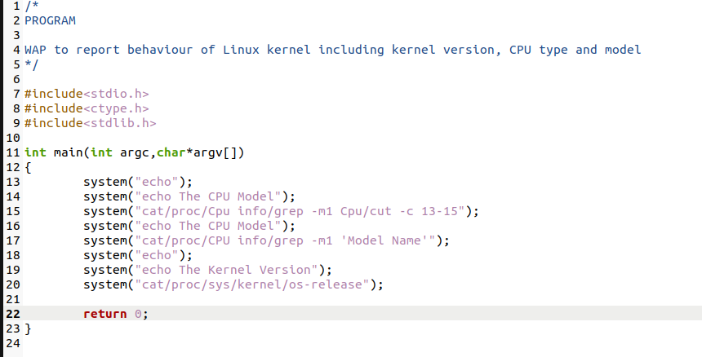

Output :- 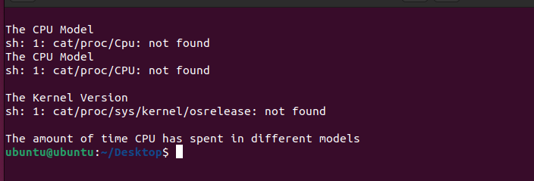

Q -6) Write a c program to roport behavior of Linux kernel including information on configured memory ,amount of free and used memory.

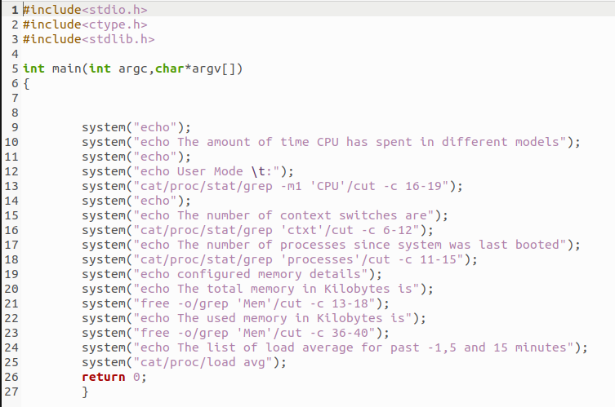

Output :-

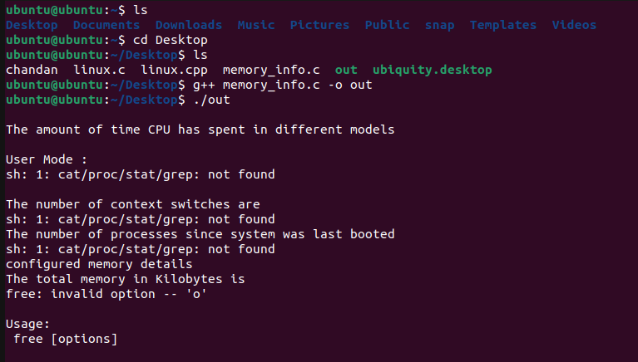

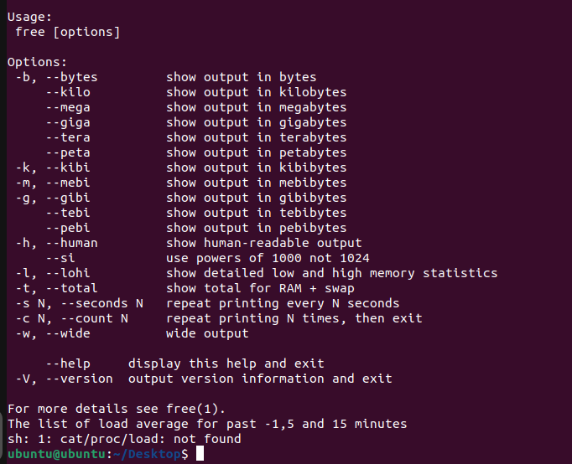

Q-7) Write a c program to copy files using system calls.

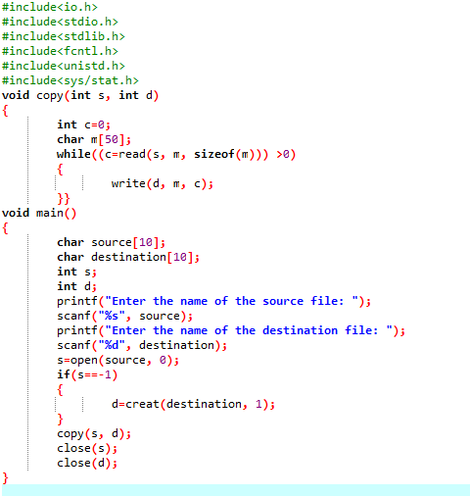

Output:-

